Scoil Mhuire
Cloonanaha National School

Health and Safety Statement

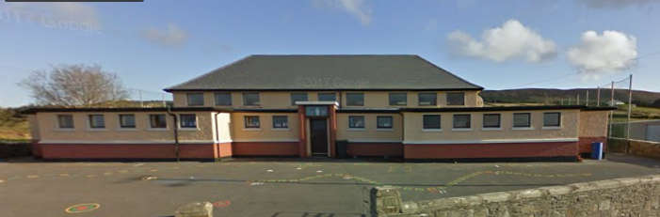

Prepared by:
Aisling Rynne

SAFETY STATEMENT

DISCLAIMER
This Safety Statement has been produced by a student in part fulfilment of the MSc Occupational and Environmental Health and Safety course at National University of Ireland, Galway.
As students are learning to write Safety Statements there may be deliberate omissions (due to time constraints), inaccuracies or insufficient information in the work to allow it to be used by the host organisation. The National University of Ireland, Galway therefore takes no responsibility for any subsequent actions, pronouncements or decisions by the host organisation on foot of its contents.

Table of Contents

Section 1: Health & Safety and Welfare Policy 1

Section 2: General Requirements 3
2.1 Introduction 3
2.2 Statement of Intent 3
2.3 Requirements within the Law 4

Section 3: School Profile and Organisational Structure 5
3.1 School Profile 5
3.2 Organisational Structure 5

Section 4: Role Responsibilities 7
4.1 Responsibilities of the Board of Management: 7
4.2 Role of the Principal (Health and Safety Co-ordinator) 7
4.3 Role of All Staff 8
4.4 Roles Specific to Teaching Staff 9
4.5 Role of Other School Users 9
4.6 Role of Contractors 10

Section 5: Safe Working Arrangements 11
5.1 Resources 11
5.2 Training and Safety Induction 11
5.2.1 Training 11
5.2.2 Safety Induction 12
5.2.3 Records 12
5.3 Personal Protective Equipment (PPE) 12
5.4 Safety Representative 13
5.5 Welfare Facilities 13
5.6 Control of Contractors 13
5.7 Monitoring & Revision 14

Section 6: Accident and Emergency Response 15
6.1 Accident Emergency Response Procedure 15
6.1.1 Minor Accident/Injury 15
6.1.2 More Serious Accidents/Injuries 15
6.1.3 Very Serious Injuries 16
6.2 Fire Emergency Response Procedure 16
6.3 Contacting the Emergency Services 17
6.4 Fire Prevention 17
6.5 Natural Disaster Emergency Response 18
6.6 First Aid and Training 18
6.7 Incident, Accident and Dangerous Occurrence Investigation and Reporting 19

Section 7: Health and Welfare Concern 20
7.1 Work-related Stress 20
7.2 Musculoskeletal Disorders 20
7.3 Pregnant Employees 21
7.4 Smoking 21

Section 8: Hazard Identification and Risk Control Measures 22
8.1 Hazard Identification 22
8.1.1 Hazard 22
8.1.2 Risk: 23
8.1.3 Risk assessment: 23
8.2 Risk Control Measure 23
8.2.1 Hierarchy of Controls 23
8.2.2 The General Principles of Prevention 25
8.3 Risk Assessment Methodology 25
8.3.1 Risk Magnitude Matrix 25
8.3.2 Probability 26
8.3.3 Severity 26
8.3.4 Risk Level Definitions 27
8.3.5 Risk Assessment Considerations 27
8.3.6 Explanation of Risk Assessment Template 28

Section 9: Risk Assessments 29
RISK ASSESSMENT -Fire 29
RISK ASSESSMENT- Slips, Trips and Falls 31
RISK ASSESSMENT- Chemical Exposure 34
RISK ASSESSMENT- Electricity 36
RISK ASSESSMENT- Maintenance Activities 38
RISK ASSESSMENT- Drop Off/ Pick Up//Traffic 40
RISK ASSESSMENT- Broken Glass 41
RISK ASSESSMENT- Knives and Cutters 44
RISK ASSESSMENT- Workplace Stress 45
RISK ASSESSMENT- Manual Handling 46
RISK ASSESSMENTS- Visual Display Units (VDUs) 47
RISK ASSESSMENT- Pregnant, Postnatal, Breastfeeding Employees 48
RISK ASSESSMENT- Boiler House/ Oil tank 49

References: 50
Appendices: 51
Appendix A Glossary of Useful Terms 51
Appendix B: Guidance on Relevant Legislation 53
Appendix C Applicable Training Courses: 55
Appendix D: Template for Training Records 56
Appendix E: Policy on Personal Protective Equipment 57
Appendix F: Template of Inspection Check Sheet for each classroom 58
Appendix G: Emergency Contact Information 59
Appendix H: Recommended Contents of First Aid Box 60
Appendix I: Sample Accident or Incident Record Form 61
Appendix J: HSA guidance on Workplace stress 63
Appendix K: Advice on reducing the risk of injury related to Manual Handling 64
Appendix L: HSE guidance on correct use of VDU equipment 67

Section 1: Health & Safety and Welfare Policy
The Board of Management of Scoil Mhuire Cloonanaha N.S are firmly committed to a policy promoting high standards of safety, health and welfare within our school. In accordance with the Safety, Health and Welfare at Work Act (SHWWA) 2005, we aim to ensure the safety, health and welfare at work of all staff and to protect students, visitors, contractors and other persons at the school from injury and ill health arising from any work activity. We recognise that the successful implementation of this policy requires the full support and active co-operation of all staff, students, contractors and visitors to the school. We aim to continually improve our safety performance by creating a safe working environment with a zero-accident rate.
In accordance with Section 20 of the SHWWA 2005, this safety statement outlines the policy of Scoil Mhuire Cloonanaha N.S. with regards to the management of health and safety within the school. We are committed to directing and implementing activities in a manner that ensures so far as is reasonably practicable, the safety, health and welfare at work of all staff and strives for continual improvement of safety management systems.
This will be achieved by:
- Managing and conducting school activities in a manner that ensures the safety, health and welfare of staff and others.
- Preventing improper conduct or behaviour (including bullying and harassment) that may result in exposing staff and others to risks affecting safety, health and wellbeing.
- Providing safe means of access and egress.
- Providing safe equipment, articles and substances that are without risk to health.
- Providing safe systems of work.
- Providing appropriate information, instruction, training and supervision to staff and all concerned.
- Determining and implementing appropriate preventative and protective measures.
- Providing and reviewing of emergency plans.
- Designating staff for emergency duties.
- Providing welfare facilities.
- Reporting necessary accidents and dangerous occurrences to the Health & Safety Authority.
- Obtaining the services of competent persons to advise and assist maintaining health and safety.
We are committed to playing an active role in the implementation of this occupational safety, health and welfare policy and undertake to review and revise it in light of changes in legislation, experience and other relevant developments.

Signed: ______________________ Date: __________
Chairperson,
Board of Management,
Scoil Mhuire Cloonanaha N.S.

Section 2: General Requirements

2.1 Introduction

In Ireland, the Board of Management as the employer, is responsible for ensuring as far as reasonably practicable, the safety, health and welfare at work of its employees and the safety, health and welfare of those who are in anyway affected by the work activities of the school. It is a legal requirement under the Safety, Health and Welfare at Work Act (SHWWA) 2005, for every employer, in conjunction with employees, to prepare a Health and Safety Statement. This document represents the Board of Management’s commitment to safety and health, and specifies the manner, the organisation and the resources necessary for maintaining and reviewing safety and health standards. The Board of Management is required to document the school’s health and safety statement and make it available to all employees, outside services providers, and Inspectors of the Health and Safety Authority. The Board of Management must also consider its ‘duty of care’ in the school and this must be an integral part of any Health and Safety statement.

2.2 Statement of Intent
This safety statement has been completed to comply with the relevant legislation as outlined in Section 2.3. The purpose of this safety statement is to assist Scoil Mhuire Cloonanaha NS in the area of safety, health and welfare within the school and to provide a system wherein certain safety issues can be addressed and managed effectively. It is necessary to update this safety statement if any changes occur in the future as stipulated in section 20, subsection 5.
The following matters will be addressed in this safety statement:

- The organisational health, safety and welfare structure within the school.
- The duties of the employer, employees, and other members of the school community in relation to safety, health and welfare of all individuals.
- The provision of safe working arrangements including resources, induction and training, appointment of a Safety Representative, employee co-operation, provision of Personal Protective Equipment (PPE), welfare facilities, control of contractors, pregnant employees, and monitoring and revision of this safety statement.
- Accident and emergency plan procedures.
- Incident and investigation reporting procedures.
- Health and welfare considerations.
- Arrangements to ensure the safety and health of relevant personnel within the school and visitors.
- Hazard Identification and Risk Assessment.
A Glossary of useful terms has been included in Appendix A.

2.3 Requirements within the Law
The Safety, Health and Welfare at Work Act (SHWWA) 2005 outlines the requirements to maintain the safety of the workplace by conducting risk assessments and identifying hazards that may be present within the workplace. In addition, it describes the requirement that every employer and relevant personnel must ensure a written safety statement is comprised wherein hazards are identified and risks are assessed while also demonstrating how the safety, health and welfare of employees and other relevant personnel is maintained. The Safety, Health and Welfare at Work (General Application) Regulations 2007 replace, simplify, and update many older regulations that apply to all places of work. The regulations set out requirements concerning manual handling of loads, electricity, noise, display screen equipment (DSE), personal protective equipment (PPE), first-aid, etc. The Fire Services Act 1981 and The Occupiers’ Liability Act 1995 are also applicable to schools (See Appendix B for more information).

Section 3: School Profile and Organisational Structure

3.1 School Profile
Scoil Mhuire is a two-teacher co-educational primary school under the patronage of the Catholic Bishop of Killaloe. It is a rural school situated on the main Inagh to Miltown Malbay road in Co. Clare. The school building comprises of two classrooms, general-use room, two offices, male and female toilets, staff toilet, hallway, indoor play area and a boiler house. There is an outdoor playground, adjoining carpark and a storage unit (enclosing the oil tank) also on the school grounds.

Assembly Point
Main Entrance
Car Park
Oil tank
Main playground
Figure 1: Aerial photograph of the grounds of Scoil Mhuire Cloonanaha NS

3.2 Organisational Structure
Current positions/roles held within Scoil Mhuire Cloonanaha NS (to be updated as needed):
Chairperson of Board of Management: | Ms Mary Crawford
Principal (Health and Safety Co- Ordinator/ First Aider): | Mr Sean O’Grady
Vice Principal (First Aider): | Ms Catherine O’Connell
Safety Officer: | Mr Declan Fox
Special Needs Assistant: | Ms Lorraine Foudy
School Secretary: | Ms Mary Rynne
School Cleaner: | Ms Mary Rynne

Safety, health and welfare is everyone’s responsibility. The organisational chart below reflects a holistic school approach to the promotion and development of safety, health and welfare within Scoil Mhuire Cloonanaha NS.
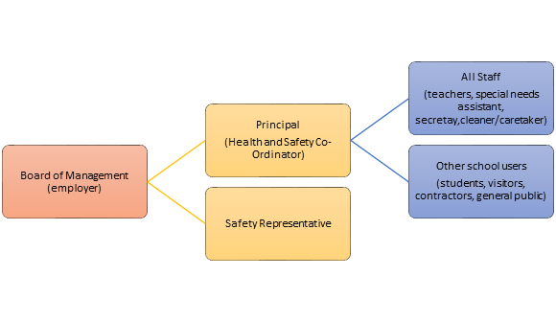

Figure 2: Organisational health, safety and welfare management structure of Scoil Mhuire Cloonanaha NS.

Under the duties specified in section 7 and section 8 of the Safety, Health and Welfare at Work Act 2005, the Board of Management as the employer, is responsible for ensuring as far as reasonably practicable, the safety, health and welfare at work of its employees and the safety, health and welfare of those who are in anyway affected by the work activities of the school. Although the Board of Management may delegate duties to employees to act on its behalf in order to manage day-to-day safety, health and welfare in the school, ultimate responsibility for safety, health and welfare lies with the Board of Management.

Section 4: Role Responsibilities

4.1 Role of the Board of Management:
As the employer, the Board will:
- Comply with its legal obligations as an employer under the 2005 Safety, Health and Welfare at Work Act
- Prepare a safety statement and regularly update it, particularly when there have been significant changes or when the risk assessment is no longer valid.
- Review the implementation of the Safety Management System and the safety statement.
- Ensure that risks are assessed and hazards are eliminated or minimized as far as is reasonably practicable.
- Allocate adequate resources to deal with safety, health and welfare issues.
- Review the school’s safety, health and welfare performance.
- Appoint competent persons as necessary, to advise and assist the Board of Management on safety, health and welfare at the school.
- Only employ competent and certified contractors who have their own up-to-date safety statement when maintenance is to be carried out within the school

4.2 Role of the Principal (Health and Safety Co-ordinator)
The role of Health and Safety Co-ordinator within Scoil Mhuire is performed by the Principal. As part of this role he/she will:

- Comply with the requirements of the Safety, Health and Welfare at Work Act 2005 by co-ordinating the school’s health and safety management system on a day-to-day basis.
- Ensure that all employees have access to the Health and Safety Statement and have read and understood it.
- Monitor the systems for ensuring that fire precautions are adequate by carrying out safety audits and organising emergency evacuations and fire training.
- Ensure regular inspections of the premises are carried out and remedial action taken where necessary.
- Ensure that induction and safety training of all employees is carried out.
- Communicate regularly with all members of the school community including the Board of Management on safety, health and welfare performance within the school.
- Ensure that all relevant accidents and dangerous occurrences are investigated and, if necessary, reported to the H.S.A. (Health & Safety Authority).

4.3 Role of All Staff (including teachers, Special Needs Assistant (SNA), school secretary and cleaner/caretaker)
All staff are required to co-operate fully with the employer so that appropriate safety, health and welfare policies are established, implemented and adhered to. All staff must:
- Take reasonable care to protect his or her safety, health and welfare and the safety, health and welfare of any other person who may be affected by his or her acts and omissions at work.
- Comply with all statutory obligations on employees as designated under the 2005 SHWWA.
- Read and understand the Safety Statement and carry out their work in accordance with its requirements.
- Co-operate with school management in the implementation of the safety statement.
- Inform students of the safety procedures associated with individual subjects, rooms, tasks.
- Ensure that students follow safe procedures.
- Formally check classroom/immediate work environment to ensure it is safe and free from fault or defect.
- Check that equipment is safe before use.
- Report accidents, near misses and dangerous occurrences to the Principal.
- Ensure they are not under the influence of an intoxicant to the extent that they may endanger themselves or others.
- Attend all necessary training and take instruction on the correct use of articles or equipment.

No staff member will:
- Interfere with, misuse or damage any safety equipment/ appliances/ facilities provided for securing the health, safety and welfare of those at work.
- Place anyone at risk in connection with work activities.

4.4 Roles Specific to Teaching Staff (including full or part-time, permanent, or temporary employees)
Teaching staff are responsible for health and safety performance and standards in respect of those activities, which are within his/her control. All teachers must ensure that he/she:

- Follows the manufacturer’s/supplier’s instructions in the use of any materials/equipment he/she is required to use in the course of his/her teaching.
- Keeps their classrooms in a neat and tidy fashion, in order to minimise the risk of accidents. Specific attention must be paid to trailing cables, spillages, and the storage of student bags and belongings.
- Displays and/or stores student work in such a manner that it does not constitute a fire risk.
- Is aware of the location of all emergency exits and fire exits and fire points; is able to recognise the fire alarm when sounded and is familiar with the evacuation procedures to be followed in the case of an emergency.
- Co-operates with the Principal and Safety Representative in matters relating to health and safety.

4.5 Role of Other School Users
Other school users such as students, parents, volunteers, and visitors are obliged to comply with school regulations and instructions relating to safety, health and welfare. They must:
- Obey all safety instructions given by the school staff.
- Co-operate with management in the wearing of the correct safety equipment, using safety devices where appropriate and following proper safe systems of work as outlined in Section 5 of this Safety Statement.
- Take care of their own health and safety by not indulging in “horseplay”, wilful unsafe acts or playing practical jokes.
- Take note of, and obey all safety signage, where necessary.

4.6 Role of Contractors
Contractors must ensure that:
- They comply with the provisions of the school’s Safety Statement and that their own company’s Safety Statement, Site Specific Safety Statement, and Method Statements (where appropriate) are made available.
- All work is carried out in accordance with relevant statutory provisions and takes into account the safety of others on the site.
- They comply with the Permit to Work system in place within the school.
- They supply and wear any personal protective equipment (PPE) as required.
- All plant and equipment brought onto the premises is safe and in good working order, fitted with any necessary guards and safety devices, and with any necessary certificates available for checking.
- They comply with any safety instructions given by site management.
- They have adequate insurance for the length of the contract.

Section 5: Safe Working Arrangements

5.1 Resources
The Board of Management aims to prioritise funding for the health, safety and welfare procedures and policies described in this Safety Statement. They ensure that sufficient numbers of experienced staff trained in safety are available for all work activities. Health and Safety considerations are incorporated in annual estimates for running of the school. Management will provide adequate resources for continuous assessment of Health and Safety policies, procedures and training within the school. The allocation of resources will be reviewed and amended as need arises.

5.2 Training and Safety Induction

5.2.1 Training
Training of all staff will be in accordance with sections 8 and 10 of the SHWWA 2005 which obliges all employers to provide training, instruction and supervision to employees regarding health, safety and welfare at work. The Board of Management are committed to the provision of adequate information, instructions, training and supervision where necessary to employees and contractors ensuring they are aware of hazards of specific activities and the necessary safety precautions so far as is reasonably practicable which are outline in the safety statement.
The school will prepare an annual safety, health and welfare training schedule, which will identify health and safety training needs for specific groups.
The school shall provide the following training as appropriate:
- Safety induction training for all new staff.
- Manual handling, first aid, and fire safety training as necessary.
- Management training to ensure that senior staff are equipped to undertake their health and safety duties and responsibilities.
Information from the H.S.A on all training applicable to staff working in Scoil Mhuire Cloonanaha NS is included in Appendix C.

5.2.2 Safety Induction
It is the policy of Scoil Mhuire Cloonanaha that all new personnel receive induction training. New employees will be shown where the Safety Statement is kept and be expected to familiarise themselves with it and understand their responsibilities.
Management will provide induction training to ensure that new staff:
- Know where the First Aid equipment is stored and who the first aider is.
- Know where to find and how to use Fire Fighting appliances.
- Are aware of fire and evacuation procedures and the location of the designated assembly point.
- Understand the importance of reporting and rectifying any defects in furniture/ equipment promptly.
- Understand procedures to undertake in the event of an accident in particular highlighting the importance to record all accidents.

5.2.3 Records
All safety training and information provided will be recorded by the school Principal. The school will keep Health & Safety training records detailing the following:
- Names of employees in attendance at training sessions.
- Dates of training and dates of when training needs to be updated.
- Training details and methods used.
- Signatures of the trainer and employee(s) to ensure that the training has been carried out.
A template for training records is attached in Appendix D.

5.3 Personal Protective Equipment (PPE)
Personal Protective Equipment (PPE) is an apparatus or device which is worn by an individual to provide protection against hazards. Schedule 2 of the SHWW (General Application) Regulations 2007 outlines the list of work activities and sectors that require PPE. The results of risk assessments carried out on work activities will dictate suitable PPE that is necessary. PPE will be provided to relevant personnel working within Scoil Mhuire e.g. cleaners, caretaker. Maintenance workers or contractors must supply their own PPE in accordance with their own Site-Specific Safety Statement. See Appendix E for policy on PPE.

5.4 Safety Representative
It is the policy of Scoil Mhuire Cloonanaha NS to communicate directly with the elected Safety Representative regarding issues related to health, safety and welfare of all individuals within the school. The Safety Representative’s role is outlined in the SHWWA 2005 and includes:
- Representing employees on safety, health and welfare issues.
- Conducting safety, health and welfare inspections (after giving reasonable notice to management).
- Investigating accidents and dangerous occurrences (without interfering with the scene of any accident).
- Liaising with the Health and Safety Authority (H.S.A) inspectors.
- Participating on the safety committee if one is established.
- Making verbal or written representations on employees’ behalf.
The Safety Representative will be provided with:
- All information necessary to fulfil their role.
- Notice when a H.S.A. inspector is assessing the school.
- Support in carrying out functions and in decision making
- Allocated time for training.

5.5 Welfare Facilities
At present, the Board of Management are in the process of upgrading welfare facilities within the school to include a private staff room. All welfare facilities are to be maintained in good order and cleaned regularly.

5.6 Control of Contractors
During maintenance work, conditions are very different from these normally encountered and new hazards may be introduced. It is essential that everyone concerned is aware of the hazards and the correct precautions are adopted. All contractors must supply a copy of their Safety Statement. Method statements will also be obtained from all contractors carrying out high-risk activities. Contractors will also be obliged to have relevant Contractor Liability Insurance when carrying out any form of maintenance on school grounds.

5.7 Monitoring & Revision
The Board of Management will ensure that safety performance is monitored and systems revised where necessary. This will be achieved in the following manner:
- All employees are expected to bring to the notice of the Principal any areas where the policy on health, safety and welfare appears to be inadequate and request an amendment to be made to the Safety Statement.
- Such information will be communicated directly to management or through the Safety Representative and this will ensure that the Safety Statement is monitored on a continuous basis.
- The Principal in conjunction with the Board of Management will ensure that the Safety Statement is regularly updated (to reflect changes in legislation, staff or work practices etc.) and employees will be informed of the changes.
- The school will undertake, on a regular basis, safety inspections and apply a risk assessment of High, Medium or Low and time scale to address same together with the person assigned to implement the necessary corrective measures. A template for a classroom inspection/audit checklist is attached in Appendix F.

Section 6: Accident and Emergency Response
The occurrence of an emergency is always a possibility. Therefore, it is vital to establish and maintain pre-planned procedures in order to respond effectively and efficiently to accidents and emergency situations. The purpose of these procedures is to ensure the safety, health and welfare of all staff, students and visitors in Scoil Mhuire Cloonanaha NS. It is the responsibility of the Principal (Health and Safety Co-ordinator) to:
- Identify and respond to emergency situations.
- Prevent and mitigate the impact of actual emergency situations.
- Consider the health and safety aspect of all parties on school grounds.
- Review and test the emergency response procedure on a continual basis so as to ensure familiarity with necessary measures in a timely manner.

6.1 Accident Emergency Response Procedure
In the event of an accident involving injury, the staff member present will assess the injury and in consultation with the Principal and the First Aider decide on the appropriate response.

6.1.1 Minor Accident/Injury
The injured party will initially be looked after by the teacher on duty. If deemed necessary, the child will be taken inside to their classroom. No medicines will be administered but cuts will be cleaned with anti-septic wipes and bandages/plasters applied if deemed appropriate. The use of plastic gloves is advised at all times. Parents are notified as a matter of protocol.

6.1.2 More Serious Accidents/Injuries
If considered safe to do so, the injured party will be taken inside to their classroom. Parents/guardians will immediately be informed, particularly if there is a suspicion of broken bones, head or eye injuries. The child is kept under intense observation until parents/ guardians arrive, with the emphasis on making the child as comfortable and as settled as possible.

6.1.3 Very Serious Injuries
In the event of a very serious injury, parents/guardians will be immediately contacted. If the considered opinion of the staff is that immediate professional help is required, an ambulance or local GP will be called. Parents will be kept informed of developing situations.

6.2 Fire Emergency Response Procedure
In the event of a major fire the following actions should be taken:
- Sound the alarm by shouting the word ‘FIRE’ repeatedly to alert others.
- Go to designated assembly point.
- Principal/ Teacher in charge must call the Fire Brigade immediately.
- All staff should check toilets on their way past.
- As soon as classes and groups are assembled each teacher will take a roll call.
- Report to the Principal if anyone is missing.
- An immediate check must be made by staff if any person is missing.
- Do not return to building until deemed safe to do so by a Firefighter.
- The designated assembly point is located at:
PLAYGROUND AT FRONT OF SCHOOL 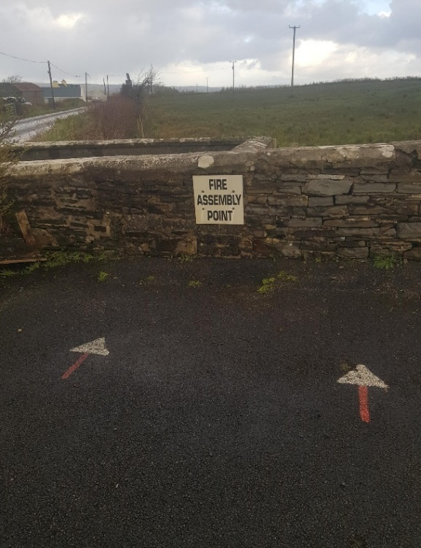
Figure 3: Signage displayed within Scoil Mhuire Figure 4: Designated Assembly Point

6.3 Contacting the Emergency Services

If you are the person contacting the Emergency Services, follow these steps:
- Dial 999/112
- Ask for Fire Services/Ambulance/Gardaí
- Recite clearly the school’s Eircode: V95 HN76
- Give an indication of:
  - The number of persons in the school injured.
  - A brief description of how the incident/accident occurred.
  - An exact location of the accident within the school.
  - The best point of entry for Emergency Services.
  - Any specific hazards that are in the school that they can be exposed to such as flammable liquids/gases.
See Appendix G for Emergency contacts and numbers

6.4 Fire Prevention

There is always a danger of fire or other emergencies occurring which will necessitate prompt evacuation of the building. Fire extinguishers are provided on the premises and are regularly checked. The following precautions are in place:
- Instruction and training of staff in fire and emergency evacuation procedures, the location of fire points, and the use of firefighting equipment.
- Fire and evacuation drills at least once per term.
- Provision and regular maintenance of escape routes and exits which are unlocked, operational and free from obstruction.
- Provision of adequate fire protection equipment and systems.
- Regular inspection and maintenance of fire protection equipment and systems.
- Maintenance of good housekeeping practices to ensure the removal of all combustible rubbish.
- Testing and maintenance of electrical installations ensuring that all electrical equipment is switched off and unplugged when not in use (where practicable).
Fire extinguishers in place in Scoil Mhuire:
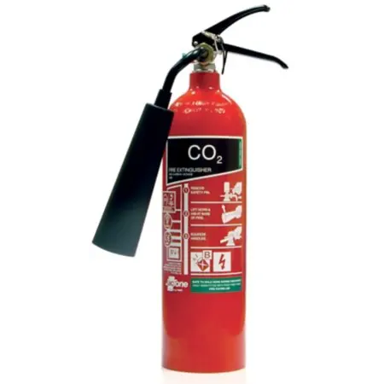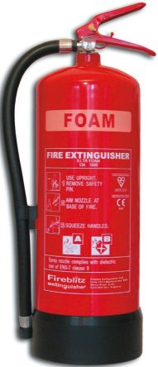
Figure 5: CO2 Extinguisher (Black) Figure 6: Foam Extinguisher (Cream)
CO2 Extinguishers can be used on all fires Foam Extinguishers can be used on oils, combustible materials

Fire extinguishers are located in the following locations:
Secretary’s office- CO2 and Foam
General Use Room- CO2
Principal’s Classroom- CO2
Main Corridor- Foam

6.5 Natural Disaster Emergency Response
In the event of a natural disaster consult the school’s Critical Incident Policy.

6.6 First Aid and Training
While aiming to prevent accidents, it is acknowledged that there may be unforeseeable accidents. For this reason, a First Aid Box is provided for use in the school and is located in an easily accessible location as highlighted below. Contents of the first aid box are checked regularly. Where necessary, the Principal is notified of the need to reorder stock. The school will provide training in First Aid to the nominated first-aider. This training will be reviewed and updated every two years or earlier if required. One first-aider and one first aid kit is sufficient for the population of the school as per the H.S.A.’s guidelines. See Appendix H for H.S. A.’s recommendations on what should be contained in the First Aid Box.

LOCATION OF FIRST AID BOX:
Bookshelf in Principal’s Classroom

6.7 Incident, Accident and Dangerous Occurrence Investigation and Reporting
All accidents to persons which take place in the school grounds, whether or not in the employment of the school resulting in injury, however slight, must be reported immediately to the Principal. If an accident, either at the place of work or related to a place of work or work activity, causes loss of life to a person or disables any person for more than three calendar days, not including the day of the incident, from performing his/her normal duties of employment, the Principal must ensure that an IR1 and IR3 forms are completed as required and sent to the H.S.A. If the accident is fatal then the scene of the accident must be left undisturbed for three days after notice has been given, other than for rescue purposes. See Appendix I for a sample Accident or Incident Record Form

Section 7: Health and Welfare Concern

7.1 Work-related Stress
Work-related stress (WRS) may be brought on by or made worse because of work. It may be caused when an individual perceives real pressures, deadlines, threats or anxieties within the working environment and can bring about such feelings as an inability to cope (HSA 2009). Numerous factors at work can lead to potential stress and diminish emotional and physical well-being if they go unsupported or unchecked. Work-related stress can be detrimental to the wider workforce as well as the individual worker and so action needs to be taken. Risk assessments for work-related stress are treated like any other workplace hazard.

To reduce work-related stress, it is important that the Principal and all staff members:
- Recognise signs and symptoms of stress i.e. fatigue, upset stomach, aches and pains, tense muscles, chest pain, rapid heartbeat, insomnia, frequent colds and infections.
- Encourage open communication within their work environment in order to talk about workloads or the factors that may be causing them stress.
- Are aware of available resources such as the Work Positive tool by the HSA or www.hse.ie. See Appendix J for further information.

7.2 Musculoskeletal Disorders
Musculoskeletal disorders (MSDs) are impairments affecting some body structures such as muscles, joints, tendons, ligaments, nerves, bones and local circulatory system. Musculoskeletal disorders can affect staff members who engage in tasks involving manual handling and/or the use of Visual Display Units (VDUs).
Manual handling can become a potential workplace hazard when an employee is required to handle very heavy loads, which could result in a musculoskeletal disorder. It involves the transporting or supporting of any load by one or more employees, and includes lifting, putting down, pushing, pulling, carrying or moving a load, which by reason of its characteristics or unfavourable ergonomic conditions, involves risk, particularly of back injury, to employees.
Improper VDU setups can also contribute to musculoskeletal disorders and repetitive strain injury (as well as visual fatigue and increased stress levels) so it is vital that both Manual Handling and VDU risk assessments are carried out by a competent person to identify and correct any hazards that may exist. See Appendices K and L for advice on correct Manual Handling and VDU practices.

7.3 Pregnant Employees
It is the policy of this school to take all the necessary steps to comply with the SHWW (General Application) Regulations 2007. It is the duty of the employee to inform the Principal if they are pregnant as early as possible in the pregnancy. On receiving notification that an employee is pregnant, the school will assess the specific risk to that employee and take action to ensure that she is not exposed to any situation which could damage either her health or that of her developing child. If the assessment reveals that there is a risk, the employee will be informed and every effort will be made to eliminate exposure to this risk. Every effort will also be made to provide, where practicable, suitable working conditions and flexible working arrangements. The school fully subscribes to the provisions of the Maternity Protection Acts.

7.4 Smoking
Smoking is prohibited on the school grounds and in the school building. Second-hand smoke, also known as Environmental Tobacco Smoke (ETS) or Passive smoke is a cause of disease, including lung cancer and heart disease in third parties. Neither the simple separation of smokers and non-smokers within the same airspace, nor the provision of ventilation, can eliminate exposure to second-hand smoke and the consequent health effects of such exposure. Scoil Mhuire aims to protect all staff, students, visitors, and contractors from exposure to second-hand smoke, to ensure compliance with legal obligations, and to ensure a safe working environment as far as is reasonably practicable. The non-smoking policy within the school applies to all employees, parents, students, contractors, and visitors. All staff have an obligation to adhere to and facilitate the implementation of the policy.

Section 8: Hazard Identification and Risk Control Measures

8.1 Hazard Identification
In accordance with Section 19 of the SHWWA 2005 it is the policy of the school to identify hazards in the place of work, to access the risk to Safety and Health and to control risks as far as is practicable so that they are either eliminated or reduced to an acceptable level.

8.1.1 Hazard
A hazard is anything that has the potential to cause harm to people, property or the environment. It can be a work material, a piece of equipment, or a work method or practice.
The following hazards were identified in Scoil Mhuire Cloonanaha NS:

Chemical Hazards: | Physical Hazards: | Human Factor Hazards:
Cleaning agents and detergents  PVA glue  Inks (photocopier)  Paints (arts and craft) | Slip/trip and fall hazards  Fire hazards  Electrical hazards  Manual handling hazards  Fall from height hazards  Housekeeping hazards  Visual Display Units  Knives and cutters  Car park and traffic  Hot drinks  Broken glass  Oil- burner hazards  Maintenance hazards | Work- related stress  Pregnant employee hazards  Aggressive/violent behaviour from students  Unauthorised persons on school grounds

8.1.2 Risk:
Risk is the likelihood that someone will be harmed by the hazard together with the severity of harm suffered. Risk also depends on the number of people exposed to the hazard.

8.1.3 Risk assessment:
A risk assessment is concerned with identifying the hazard, then estimating the severity and likelihood of harm arising from such a hazard. The employer can then put in place control measures to minimize the risk or weigh up whether he or she has taken enough precautions to prevent harm.

8.2 Risk Control Measure
Risk control measures are things that can be put in place to reduce the risk from a hazard. Control measures include steps that can be taken or put in place to reduce the potential of exposure to the hazard. The control measure could also be to completely remove the hazard or to reduce the likelihood of the risk of the exposure to that hazard. When we look at control measures, we often refer to the Hierarchy of Control measures.

8.2.1 Hierarchy of Controls
Hierarchy of hazard control is a system used in industry to minimize or eliminate exposure to hazards. It is a widely accepted system promoted by numerous safety organisations. It is based on the following hierarchy of phases:
1. Eliminate the hazard | Elimination of the hazard is not always achievable though it does totally remove the hazard and thereby eliminates the risk of exposure. An example of this is having a no- smoking policy within the school- therefore eliminating the harmful effects of tobacco smoke for all individuals
2. Substitute the hazard | Substituting the hazard may not remove all of the hazards associated with the process or activity and may introduce different hazards but the overall harm or health effects will be lessened. An example of this would be replacing glass windows with laminated glass to prevent the risk of injury in the event of breakage
3. Isolate the hazard | Isolating the hazard is achieved by restricting access certain hazards. In schools this could involve locking chemicals or hazardous substances away from susceptible individuals e.g. children.
4. Use engineering controls | Engineering Controls involve redesigning a process to place a barrier between the person and the hazard or remove the hazard from the person eg ventilation systems
5. Use administrative controls | Administrative controls include adopting standard operating procedures or safe work practices or providing appropriate training, instruction or information to reduce the potential for harm and/or adverse health effects to person(s).Eg. All contractors working on school property will not be allowed work on school grounds when there is a Permit to Work system in place
6. Use personal protective equipment | Personal protective equipment (PPE) include gloves, glasses, earmuffs, aprons, safety footwear, dust masks which are designed to reduce exposure to the hazard. PPE is usually seen as the last line of defence and is usually used in conjunction with one or more of the other control measures. Eg. Cleaners should be provided with and wear appropriate gloves when working with chemicals eg. Rubber

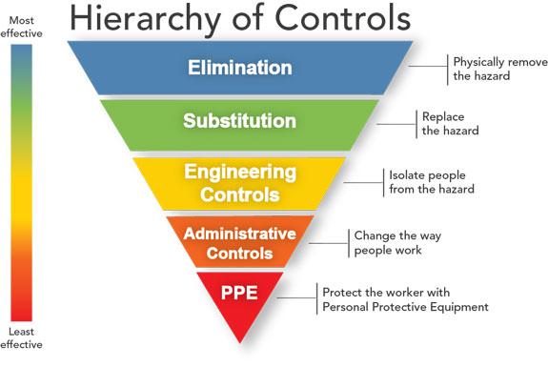
Figure 7: Hierarchy of Controls

8.2.2 The General Principles of Prevention
The General Principles of Prevention (outlined in Schedule 3 to the Safety, Health and Welfare at Work Act 2005) provide a methodology for approaching accident prevention. The Board of Management will take account of these principles when implementing necessary safety, health and welfare measures in the school.
The Nine Principles include:
1. The avoidance of risks
2. The evaluation of unavoidable risks
3. The combating of risks at source
4. The adaptation of work to the individual
5. The adaptation of the place of work to technical progress
6. The replacement of dangerous articles, substances or systems of work by safe or less dangerous articles, substances or systems of work
7. The giving of priority to collective protective measures over individual protective measures
8. The development of an adequate prevention policy in relation to safety, health and welfare at work, which takes account of technology, organisation of work, working conditions, social factors and the influence of factors related to the working environment
9. The giving of appropriate training and instructions to employees.

8.3 Risk Assessment Methodology

8.3.1 Risk Magnitude Matrix
Two elements are determined when assessing the level of risk posed by the risk that has been identified:
- The likelihood that a risk may occur or reoccur.
- The impact of harm to service users, staff, services, environment or the organisation.
RISK RATING = PROBABILITY X SEVERITY

8.3.2 Probability
The probability of the identified hazard occurring is then assessed using the following criteria:
- High = Very likely that the event will occur
- Medium = reasonably possible that the event will occur
- Low = Unlikely that the event will occur

8.3.3 Severity
The consequences of the identified health safety hazards shall be assessed using the following criteria:
- High = Fatality/major injury or illness causing long-term disability
- Medium = Injury or illness requiring further medical assistance
- Low = Minor injury requiring first aid
Figure 8: Risk Rating Matrix

8.3.4 Risk Level Definitions *

Low Risk | Largely acceptable, subject to reviews periodically or after significant changes etc. Activities in this category contain minimal risk and are unlikely to occur. Organizations can proceed with these activities as planned.
Medium Risk | Activities in this category contain some level of risk and efforts should be made to mitigate the risk. Where the medium risk is associated with extremely harmful consequences, further assessment maybe necessary to establish more precisely the likelihood of harm, this as a basis for determining the need for improved control measures.
High Risk | Activities in this category contain potentially serious risks that are likely to occur. Application of proactive risk management strategies to reduce the risk is advised. Organizations should consider ways to modify or eliminate unacceptable risks. Significant resources may have to be allocated to mitigate the risk. Where the risk involves work in progress, urgent action should be taken.
*(Note: When dealing with a workplace such as a school where children are present certain tasks automatically carry a higher risk rating. This is attributable to a higher probability of actions occurring such as spillages, trips, slips, falls etc.)

8.3.5 Risk Assessment Considerations
All users of the school facilities will be considered when carrying out risk assessments within Scoil Mhuire Cloonanaha N.S. This includes the following:

• Teaching staff - permanent and temporary, substitute and trainee staff
• Non-teaching staff - administration, caretaking and cleaning staff
• Contract workers such as window cleaners, painters, electricians, plumbers
• Pupils including visiting pupils, e.g. as part of a team
• Parents/guardians
• Visiting speakers
• Visiting maintenance workers
• Members of the public

8.3.6 Explanation of Risk Assessment Template

Figure 11: Risk Assessment Template and Explanation
- Title and name of the organisation
- Area/ activity/ hazard area being assessed
- Name of assessor(s)
- Reason for assessment
- Date of assessment
- Revision number
- Assessment type: initial or re-assessment
- Activity/hazard (breakdown of task/activity based on identification stage)
- Risk event: hazard effect for each activity
- Person at risk (persons potentially exposed)
- Risk Rating: Probability x Severity (High, Medium or Low ratings)
- Control Measures- measures implemented to reduce the levels of risk to as low as possible
- Additional controls or actions required- measures which if implemented would reduce risk even further
- Person responsibility for monitoring controls
- Risk Rating Key
- Probability/ Severity and Risk Rating Categories
- Risk Matrix
- Signatures of assessor and person approved by

Section 9: Risk Assessments

RISK ASSESSMENT -Fire
Hazard Identification and Risk Assessment
Scoil Mhuire, Cloonanaha N.S.

Area/Activity/Hazard Area Assessed: Fire
Assessor: Aisling Rynne
Date: 15th March 2019
Revision Number: 02
Assessment Type: Re-assessment
Hazard | Risk Event | Person at Risk | Risk Rating |  |  | Control Measures | Additional Comments/  Actions Required | Person(s) Responsible
 |  |  | P | S | RR
General Fire | Smoke Inhalation  Burns  Injury  Death | Students  All staff  Visitors | L | H | M | Use of candles or other naked flames strictly controlled  Fire extinguishers in place, accessible and maintained annually by Banner Fire Prevention  Teaching staff know how to raise the alarm and contact the emergency services  All teachers have received training on how to use fire extinguishers and fire blankets  There is an accessible fire extinguisher in each classroom or hallway close to classroom  Written evacuation plan is in place | Further consultation is needed with Banner Fire Prevention re: need for installation of Early Fire Warning System  Practice fire/evacuation drills should be held at least once per year  Additional fire training is recommended for ancillary staff | Teachers/ all staff  Board of Management  Teachers  Principal  Principal/ Board of Management
Restricted Access/Egress | Delays in exiting building in the event of a fire  Smoke Inhalation  Burns  Death | Students  All staff  Visitors | L | H | M | Exit routes kept free from obstruction  External lighting on exit routes is operational  Fire assembly point is identified  Principal is designated to raise the alarm and contact the emergency services | Green ‘Fire Assembly’ signage in line with EU regulations is recommended due to poor visibility of existing sign | All staff  Principal  Board of Management  Principal
Electrical Fire | Fire  Burns  Death | Students  All staff  Visitors | L | H | M | Visual checks on all electrical equipment and power points are carried out regularly by all staff  Defects in equipment are reported to the Principal immediately to ensure all items are repaired or replaced. | Defective electrical equipment should be clearly identified, labelled as out of use, and stored separately to prevent accidental use | All staff

Performed by_____________ Date___/___/___ Approved by_________________

RISK ASSESSMENT- Slips, Trips and Falls
Hazard Identification and Risk Assessment
Scoil Mhuire, Cloonanaha N.S.

Area/Activity/Hazard Area Assessed: Slips, Trips and Falls
Assessor: Aisling Rynne
Date: 15th March 2019
Revision Number: 02
Assessment Type: Re-assessment
Hazard | Risk Event | Person at Risk | Risk Rating |  |  | Control Measures | Additional Comments/  Actions Required | Person(s) Responsible
 |  |  | P | S | RR
Spills, e.g. liquid spills, drinks, art/crafts materials | Injury from slip, trip, fall | All staff  Students  Visitors | H | M | H | Spills are dealt with immediately  Absorbent material is used to soak up the spill  Absorbent material is located near high spill risk areas eg hand towels near sinks | *Risk Rating is higher due to presence of children  ‘Wet Floor’ sign should be put in place. | All staff  All staff  Cleaner
Inadequate storage of school equipment and personal belongings | Injury from slip, trip or fall | All staff  Students  Visitors | H | M | H | School bags stored tidily  Student belongings stored on hooks or safely under desks | Floors and access routes should be kept clear  Suitable storage area is required for students to store their hurleys and helmets.  A secure storage area is required for storage of cleaning equipment eg. Mop and bucket, sweeping brushes | Teachers  Teachers  Board of Management/ cleaner
Trip hazards including trailing cables and electrical leads | Injury from slip, trip or fall | All staff  Students  Visitors | H | M | H | Caution is taken to avoid trailing cables and leads | Overloading of sockets with multiple appliances in both classrooms should be avoided if possible.  Retractable reels should be used if above is not feasible. | All staff
Cleaning and washing floors | Injury from slip, trip or fall | Cleaner (floors are not washed during school hours) | M | M | M | Cleaning and washing of floors is performed outside of school hours.  Excess liquid is removed to assist the floor drying process.  As far as possible, the floor is cleaned until dry | A system is advised to keep pedestrians away from wet/ moist floors, e.g. wet floor signs | Cleaner
Inadequately fitting rugs or mats | Injury from slip, trip or fall | All staff  Students  Visitors | L | M | L | Mats and rugs are properly designed/fitted  Heavy mats are used as necessary  Weighted edges are used where possible or edges are fixed in place |  | Principal/ all staff
Slippery surfaces  Eg. Toilet floors, Area by Front door | Injury from slip, trip or fall | All staff  Students  Visitors | M | M | M | All areas prone to constant wetting are identified and monitored regularly  Anti-slip tiles are in place  Limit on numbers using toilet facilities at any given time | Particular attention must be paid to areas that may become slippery during severe weather | All staff/ Cleaner  Principal/Board of Management  Teachers
Inadequate housekeeping | Injury from slip, trip or fall | All staff  Students  Visitors | M | M | M | All bins are empties regularly to prevent overflow of contents.  All waste boxes or containers are removed after completing tasks and placed in bins. | All floors, aisles and corridors should be kept free of any trip or slip hazards. Extension leads/ hurleys/helmets in both classrooms should be relocated | Cleaner (all staff when cleaner not present)  Staff member performing task
Broken Furniture | Falls and related injuries | All staff  Students  Visitors | L | M | L | Broken furniture removed from service until repaired or replaced | Regular routine of assessing furniture should be introduced | All staff
Inappropriate behaviour  ‘horseplay’ | Injury from slip, trip or fall | Students | M | M | M | Rules to prevent running and ‘horseplay’ in hallways and corridors are strictly enforced  Supervision provided during lunchtimes and end of day | *Risk Rating is higher due to presence of children | Teachers  Teachers/SNA
Playground | Injury from slip, trip or fall | Students | H | M | H | Play periods are supervised and a yard rota is in place  Students and staff have been informed of the established school Code of Behaviour.  Rough or dangerous play is outlawed  Playground is maintained to a high standard  Boundary wall is maintained | *Risk Rating is higher due to presence of children | Teachers  Teachers  Board of Management
Damaged flooring/ paving | Injury from slip, trip or fall | All staff  Students  Visitors | M | M | M | Poorly maintained or damaged floors or paving is identified  Repairs carried out and steps taken to prevent future damage | Regular routine of assessing flooring/ playground should be introduced | All staff  Board of Management
Slippery walkways due to excessive weather conditions Eg Ice, rain | Injury from slip/fall | All staff  Students  Visitors | M | M | M | No controls | Salt should be made available for slippery footpaths/ playground during icy conditions | Principal

Performed by: _____________ Date___/___/___ Approved by_________________

RISK ASSESSMENT- Chemical Exposure
Hazard Identification and Risk Assessment
Scoil Mhuire, Cloonanaha N.S.

Area/Activity/Hazard Area Assessed: Chemical Agents
Assessor: Aisling Rynne
Date:15th March 2019
Revision Number: 02
Assessment Type: Re-assessment
Hazard | Risk Event | Person at Risk | Risk Rating |  |  | Control Measures | Additional Comments/  Actions Required | Person Responsible
 |  |  | P | S | RR
Contact with chemical cleaning products  Disinfecting agents found in Scoil Mhuire:  Domestos, Flash, Parazone, Pledge, Jif, HG drain unblocker | Skin Irritation Splashes (eyes) Allergies  Ingestion  Burns | Cleaner  Students  All staff | L | H | M | Chemical products are labelled and locked away and only authorised staff have access to the storage area  When choosing chemical cleaners, the least hazardous chemical is purchased  Personal protective equipment (PPE) is provided and worn by the cleaner when using products  Bleach and acidic toilet cleaners are never mixed or put into toilet bowl together | ‘Chemical hazard’ signage should be put in place where chemicals are stored | Cleaner  Cleaner/Principal  Cleaner/ Board of Management  Cleaner
Fumes from paints and glues  The following is a list of chemical hazards found:  Water- based paints (Creall and Bramle brands)  PVA glue  HP Inks (photo copier) | Respiratory irritation | Students  All staff | L | M | L | Relevant employees are aware of the hazards and precautions that must be taken when using chemical products/materials  Students are unauthorized to access paints/ glues without staff permission  Students are supervised at all times when accessing and utilising chemical products such as paints/glues.  Ink cartridges are locked away in secretary’s office | Safety Data Sheets (SDS) must be obtained for all chemicals and a copy kept on file in a suitable location, accessible by relevant employees | All staff  Secretary
Improper storage of solvents and flammable materials | Fire causing death or injury,  AsphyxiationExplosion | Students  All staff  Visitors | L | H | M | Solvents or other highly flammable materials are stored in metal cabinets  Users of chemicals are aware of the hazards and precautions that must be taken when using chemical products.  Combustible materials are stored in appropriate conditions as per manufacturers storage guidelines  Chemical products are labelled and stored safely in a locked storage area | Safety Data Sheets (SDS) must be obtained for all all chemicals and a copy kept on file in a suitable location, accessible by relevant employees | Principal/ Caretaker  Cleaner  Caretaker  Cleaner/ Teachers

Performed by: ____________ Date___/___/___ Approved by_________________

RISK ASSESSMENT- Electricity
Hazard Identification and Risk Assessment
Scoil Mhuire, Cloonanaha N.S.

Area/Activity/Hazard Area Assessed: Electricity
Assessor: Aisling Rynne
Date: 12th March 2019
Revision Number: 02
Assessment Type: Re-assessment
Hazard | Risk Event | Person at Risk | Risk Rating |  |  | Control Measures | Additional Comments/  Actions Required | Person(s) Responsible
 |  |  | P | S | RR
Electrical Faults  Electrical equipment becoming live | Electrocution  Electric Shock  Fire | Students  All staff  Visitors  Contractors | L | H | M | Wiring systems are in accordance with Expert Compliance Training Institute  Maintenance carried out by Register of Electrical Contractors of Ireland (RECI) certified electrician  Isolated fuse box is in place  Emergency Shut Down ON/OFF clearly marked.  Equipment checked prior to use for faults  All electrical faults are reported to the Principal immediately.  CO2 fire extinguisher in place | Staff should avoid overloading electrical sockets by relocating unnecessary appliances to unused sockets | Board of Management  Board of Management  Board of Management  Board of Management  All staff  All staff  Principal
Defective portable electrical equipment (eg. TV, computers, photocopier, radio, DVD player, electric kettle, fridge, hoover)  Exposed wiring/live parts | Electrocution  Fire  Electric burns  Explosion | Students  All staff  Visitors | L | H | M | Appliances are only used as per manufacturer’s instructions  Defective electrical equipment isl be clearly identified, labelled as out of use, and stored separately to prevent accidental use  CO2 fire extinguishers are in place if needed in case of electric fires.  Visual checks are carried out on all equipment by staff members  Defects are reported to the Principal to ensure all items are repaired or replaced. | Visual check should include:  On/off switch is working correctly  • No signs of damage to casing  • No loose parts or missing screws  • Live parts are properly guarded so as not to be inadvertently accessible  • Cables are securely anchored to the plug with no signs of cuts, frays, brittleness, leads kinked or coiled, taped joints, overloading (overheating indicated by colour change or smell), cable cores not externally visible  • Plugs are securely anchored, no sign of cracked casing, overheating, loose or bent pins  • Socket outlets have no cracks or damage or sign of overheating | All staff
Damaged electrical fittings and equipment | Electrocution  Fire | Students  All staff  Visitors | L | H | M | All defects are reported to the Principal to ensure all items are repaired or replaced  Maintenance is carried out by Register of Electrical Contractors of Ireland (RECI) certified electrician | Defective electrical equipment should be clearly identified, labelled as out of use and stored separately to prevent accidental use. | All staff  Board of Management

Performed by: _____________ Date___/___/___ Approved by_________________

RISK ASSESSMENT- Maintenance Activities
Hazard Identification and Risk Assessment
Scoil Mhuire, Cloonanaha N.S.

Area/Activity/Hazard Area Assessed: Maintenance Activities
Assessor: Aisling Rynne
Date: 15th March 2019
Revision Number: 02
Assessment Type: Re-assessment
Hazard | Risk Event | Person at Risk | Risk Rating |  |  | Control Measures | Additional Comments/  Actions Required | Person(s) Responsible
 |  |  | P | S | RR
Use of scaffolding/ladders | Falls from height  Death | All Staff  Students  Contractors | L | H | M | All maintenance work takes place outside of school hours  All work is carried out by competent contractors who provides their own equipment  Any hazardous work areas are cordoned off and have adequate signage to notify people of dangers  Appropriate personal protective equipment is worn by contractors | Parents should not be requested to help with maintenance activities such as painting. | Board of Management/ Contractors responsible for all controls
Poorly maintained tools | Cuts  Lacerations  Eye injury | Contractors | L | H | M | Appropriate personal protective equipment is supplied and worn by contractors.  Tools used for maintenance are in good working order and properly guarded where necessary |  | Board of Management/ Contractors responsible for all controls
Exposure to chemicals | Skin Irritation Splashes (eyes) Allergies  Ingestion  Burns | All Staff  Students  Contractors | L | H | M | Waste is disposed of correctly by contractors  All work is carried out by competent contractors who provide own equipment  Chemical products are labelled and locked away and only authorised staff have access to the storage area  Appropriate personal protective equipment is worn by contractors  Only trained and authorized persons carry out maintenance tasks  Work takes place outside school hours | Safety Data Sheets must be obtained for all chemicals and a copy kept on file in a suitable location, accessible by relevant employees | Contractors  Board of Management/ Contractors responsible for all controls
Contact with bladed tools | Cuts, Lacerations,  Death | All Staff  Students  Contractors | L | H | M | Tools and dangerous equipment turned off and locked away when not in use  Only trained and authorized persons carry out maintenance tasks  Work takes place outside school hours |  | Board of Management/ Principal/ Contractors responsible for all controls
(*Note All contractors carrying out works must have contractor liability insurance)

Performed by:__________________ Date___/___/___ Approved by_________________

RISK ASSESSMENT- Drop Off/ Pick Up//Traffic
Hazard Identification and Risk Assessment
Scoil Mhuire, Cloonanaha N.S.

Area/Activity/Hazard Area Assessed: Drop off/Pick up/Traffic
Assessor: Aisling Rynne
Date: 15th March 2019
Revision Number: 02
Assessment Type: Re-assessment
Hazard | Risk Event | Person at Risk | Risk Rating |  |  | Control Measures | Additional Comments/  Actions Required | Person(s) Responsible
 |  |  | P | S | RR
Drop off/ Pick up | Abduction of students by inappropriate person  Injury  Trauma | Students | L | H | L | A protocol is in place whereby parents/ guardians inform the school if someone other than designated person is to collect student.  Front entrance to the school has an electronic door lock and intercom system which prohibits anyone entering school unless authorized by staff member  All adults are required to report to teacher’s classroom upon entering the school building. |  | Teachers/ Principal
Person being struck by vehicle | Injury /Death | Students  All staff  Visitors | M | H | H | School hazard warning lights are in pace  Suitable supervision is provided to yard/playground areas during assembly and dismissal times.  Assembly points for emergency evacuations are clearly marked and are not located in an area likely to be required by the emergency services or adjacent to main roadway | *Risk Rating is high due to presence of children  Children should not be allowed exit school grounds into car park area unless their parent/ guardian has arrived | Board of Management  Teachers  Board of Management

Performed by: _____________ Date___/___/___ Approved by_________________

RISK ASSESSMENT- Broken Glass
Hazard Identification and Risk Assessment
Scoil Mhuire, Cloonanaha N.S.

Area/Activity/Hazard Area Assessed: Broken Glass
Assessor: Aisling Rynne
Date: 15th March 2019
Revision Number: 02
Assessment Type: Re-assessment
Hazard | Risk Event | Person at Risk | Risk Rating |  |  | Control Measures | Additional Comments/  Actions Required | Person(s) Responsible
 |  |  | P | S | RR
Broken Glass | Cuts & Lacerations | All Staff  Student  Visitors | M | M | M | Glass items are prohibited within the school  Suitable cleaning material is available e.g. dustpan and brush  Broken glass is reported to staff member immediately  Ongoing supervision which identifies incidences early  All children are removed from the area immediately when broken glass occurs  Staff are trained in first aid and first aid equipment is easily accessible  Broken window is made safe until repaired  Area is cornered off until cleaned up  Only staff members are permitted to clean up broken glass | A separate waste bin for disposal of glass should be provided  Laminated glass should be used in windows where possible | Teachers/ Principal  Cleaner  All staff  Teachers  All staff  Principal/Board of Management  Caretaker  All Staff

Performed by:__________________ Date__/___/___ Approved by_______________

RISK ASSESSMENT- General School Hazards
Hazard Identification and Risk Assessment
Scoil Mhuire, Cloonanaha N.S.

Area/Activity/Hazard Area Assessed: General School Hazards
Assessor: Aisling Rynne
Date:15th March 2019
Revision Number: 02
Assessment Type: Re-assessment
Hazard | Risk Event | Person at Risk | Risk Rating |  |  | Control Measures | Additional Comments/  Actions Required | Person(s) Responsible
 |  |  | P | S | RR
Hot liquid spills from kettle | Slips, Trips, Falls  Injury  Burns | Students  All staff | H | H | H | No controls in place | Kettles should be located to restricted area which is inaccessible to students | All staff
Accessing high windows | Fall from height  Injury | Students  All staff | H | H | H | No controls in place | Climbing on furniture to open/close windows is to be strictly prohibited  Step ladder should be provided and only staff are allowed perform task | Teachers  Principal
Aggressive or violent behaviour by students | Injury | Students  Staff | L | M | L | A strict Code of Behaviour is in place in the school  All break periods are supervised by a staff member |  | Teachers
Person(s) on the premises without the knowledge of principal or other staff member | Abduction of students, Injury, Trauma, Death | Students | L | H | M | Electronic door lock and intercom system in place to monitor access to school.  All play periods supervised closely by staff member  At least one staff member remains on school grounds until all students have been collected at end of day |  | Board of Management/  Principal/ all staff
Shelving/ storage units | Collapsing  Entrapment | Students  All staff  Visitors | L | H | M | All storage/shelving units are fixed securely in place  Standing on shelving/ storage units is strictly forbidden | More storage/ shelving units are required in order to prevent existing units being overloaded with weighty products  Units should be checked regularly for metal fatigue and inspected for signs of buckling and weight tolerance | Caretaker  All staff

Performed_____________ Date___/___/___ Approved by_________________

RISK ASSESSMENT- Knives and Cutters
Hazard Identification and Risk Assessment
Scoil Mhuire, Cloonanaha N.S.

Area/Activity/Hazard Area Assessed: Knives and cutters
Assessor: Aisling Rynne
Date: 15th March 2019
Revision Number: 02
Assessment Type: Re-assessment
Hazard | Risk Event | Person at Risk | Risk Rating |  |  | Control Measures | Additional Comments/  Actions Required | Person(s) responsible
 |  |  | P | S | RR
Knives and cutters | Cuts/lacerations | Teachers  Students | M | M | M | Students are instructed in how to use knives and cutters safely.  Knives and cutters are stored separately to other equipment.  Knives are washed in sink separately from other items of equipment and never left soaking in sink. | The teacher must supervise students carefully if knives and cutters are being used in the classroom.  Knives and cutters are to be checked for damaged blades or handles once per term and disposed of if damaged. | Teachers/ SNA for all controls

Performed by: ____________ Date___/____/___ Approved By:_________

RISK ASSESSMENT- Workplace Stress
Hazard Identification and Risk Assessment
Scoil Mhuire, Cloonanaha N.S.

Area/Activity/Hazard Area Assessed: Workplace Stress
Assessor: Aisling Rynne
Date: 15th March 2019
Revision Number: 02
Assessment Type: Re-assessment
Hazard | Risk Event | Person at Risk | Risk Rating |  |  | Control Measures | Additional Comments/  Actions Required | Person(s) responsible
 |  |  | P | S | RR
Work-place Stress | Increased absences  Increased conflicts  Increased anger levels in those effected  Isolation  Low morale  Effects on physical health e.g. raised blood pressure, tension headaches.  Effects on mental health e.g. anxiety, depression, insomnia | All staff | M | M | M | The school’s Dignity in the workplace policy is communicated to all employees and is displayed in the school.  Any employee health and safety concerns in relation to their work environment are addressed in a timely manner.  There is employee input into decision-making within the school  Any Board of Management actions and decisions are made with the aim of being consistent and fair.  Employees are given training to support any changes in their jobs.  Employees are able to approach the Principal or Deputy Principal to access appropriate supports. | Staff who are showing signs of work-related stress, physically or psychologically, should be referred for further support and professional advice from the Employee Assistance and Well-being Programme from the Department of Health.  When proposed changes are implemented, the school should provide employees with timely information to enable them to understand the reasons. | Principal  Board of Management  All staff  Board of Management

Performed by: ____________ Date___/____/___ Approved By:___________

RISK ASSESSMENT- Manual Handling
Hazard Identification and Risk Assessment
Scoil Mhuire, Cloonanaha N.S.

Area/Activity/Hazard Area Assessed: Manual Handling
Assessor: Aisling Rynne
Date:15th March 2019
Revision Number: 02
Assessment Type: Re-assessment
Hazard | Risk Event | Person at Risk | Risk Rating |  |  | Control Measures | Additional Comments/  Actions Required | Person(s) responsible
 |  |  | P | S | RR
Lifting or carrying heavy loads over distances | Musculoskeletal  Injury | All staff | M | M | M | Storage of regularly accessed items are arranged so that heavier items are stored on middle shelves not on floor or above shoulder height | Work areas should be re-organised to ensure materials are stored close to point of use or source a handling aid.  Staff and Board of Management are advised on the necessity of Manual Handling training for all staff.  More shelving units needed in General Usage room to avoid ‘stacking’ of heavy containers on top of each other. | Principal/ All staff
Pushing/pulling heavy or awkward items eg. PE equipment, furniture | Musculoskeletal injury | All staff | M | M | M | Items are made lighter or less bulky where possible  Individuals ask for help when moving heavy items | Staff and Board of Management are advised on the necessity of Manual Handling training for all staff. | All staff

Performed by:_____________ Date___/___/___ Approved by_________________

RISK ASSESSMENTS- Visual Display Units (VDUs)
Hazard Identification and Risk Assessment
Scoil Mhuire, Cloonanaha N.S.
Area/Activity/Hazard Area Assessed: Visual Display Unit (VDU)
Assessor: Aisling Rynne
Date: 15th March 2019
Revision Number: 02
Assessment Type: Re-assessment
Hazard | Risk Event | Person at Risk | Risk Rating |  |  | Control Measures | Additional Comments/  Actions Required | Person(s) Responsible
 |  |  | P | S | RR
VDU usage  (VDU usage by all users is not in excess of 2 hours per day) | Eye Strain  Eye Fatigue | Secretary  Teachers | L | M | L | Offices have adequate lighting levels  Anti-glare screens in situ  Prolonged periods of working with VDU is avoided by encouraging breaks and rotating tasks | Users must be informed of their right to regular eye and eyesight tests | Principal/Board of Management
Poorly designed VDU workstation | Work related upper limb disorders i.e. neck, back, shoulder and arm pain | Secretary  Teachers | L | M | L | Workstations are assessed and setup to fit individual user  Regular breaks from working with VDU are provided | Consideration should be given to ergonomic design when purchasing new furniture | Secretary/ teachers

Prepared by:_______________ Date:___/____/____ Approved by______________

RISK ASSESSMENT- Pregnant, Postnatal, Breastfeeding Employees
Hazard Identification and Risk Assessment
Scoil Mhuire, Cloonanaha N.S.

Area/Activity/Hazard Area Assessed: Pregnant, Postnatal, Breastfeeding employees
Assessor: Aisling Rynne
Date: 15th March 2019
Revision Number: 02
Assessment Type: Re-assessment
Hazard | Risk Event | Person at Risk | Risk Rating |  |  | Control Measures | Additional Comments/  Actions Required | Person(s) responsible
 |  |  | P | S | RR
Contact with chemical agents that may be absorbed through the skin | Harm to the unborn child or breastfed babies | Pregnant, postnatal, or breastfeeding women | L | H | M | Chemical products are labelled and locked away and only authorised staff have access to the storage area  Good housekeeping is maintained. | Any chemicals with R40, R45, R61, R63 and R64 labels should not be stored in the school | Cleaner/ Principal  Cleaner/ All staff
Contact with biological agents | Infectious diseases | Pregnant, postnatal, or breastfeeding women | L | H | M | Handwashing is advised at every opportunity especially if hands are visibly soiled. | Any unwell staff member or student should be advised not to attend school until recovered. | Principal/teachers
Long periods standing, Abrupt/severe movement or postures which may give rise to fatigue | Fatigue (mental and physical)  Varicose veins | Pregnant, postnatal, or breastfeeding women | L | M | L | Pregnant, postnatal or breastfeeding women are provided with appropriate seating whilst completing work activities. | Adequate resting facilities should be made available to pregnant, postnatal or breastfeeding women. | Principal/teachers
Pushing/pulling/carrying heavy or awkward items | Manual handling induced injury | Pregnant, postnatal, or breastfeeding women | L | M | L | Heavier items are stored on middle shelves not on floor or above shoulder height.  Items are made lighter or less bulky where possible.  Individuals ask for help when moving heavy items. | Pregnant, postnatal and breastfeeding women are not required to lift, push, or pull awkward or heavy items | Principal/ all staff

Performed by: ____________ Date___/____/___ Approved By ______________
RISK ASSESSMENT- Boiler House/ Oil tank
Hazard Identification and Risk Assessment
Scoil Mhuire, Cloonanaha N.S.

Area/Activity/Hazard Area Assessed: Boiler house/ Oil Tank
Assessor: Aisling Rynne
Date: 15th March 2019
Revision Number: 02
Assessment Type: Re-assessment
Hazard | Risk Event | Person at Risk | Risk Rating |  |  | Control Measures | Additional Comments/  Actions Required | Person(s) Responsible
 |  |  | P | S | RR
Flammable oil | Asphyxiation Fire  Explosion  Burns | All staff  Students  Visitors | L | H | M | The boiler is serviced annually by a competent person and service records are maintained at the school  Smoking in or near the boiler room is prohibited  Unsafe access to boiler room is prevented and area kept locked at all times  Unauthorised persons are not permitted in the vicinity of the boiler room |  | Board of Management  All staff/ visitors  Principal  Principal
Accessibility to fuel storage tank | Slips, trips, falls  Fire Explosion | All staff  Students  Visitors | L | H | M | Oil tank is enclosed in a stone shed to prevent it being struck by a vehicle and is adequately locked and secured against vandalism or tampering |  | Board of management
Unsafe storage of materials adjacent to boiler | Fire Trip  Fall  Explosion | All staff  Students  Visitors | M | H | H | No controls in place | Combustible materials such as furniture or cardboard should not be stored in boiler room and must be removed | Principal/ Board of Management

Performed_____________ Date___/___/___ Approved by_______________

References:
Health and Safety Authority (H.S.A) (2013) Guidelines on Managing Safety, Health and Welfare in Primary Schools, Health and Safety Authority. Available at: https://www.hsa.ie/eng/Education/Managing_Safety_and_Health_in_Schools/Primary_Schools_Guidelines/Guidelines_on_Managing_Safety_Health_and_Welfare_in_Primary_Schools.pdf. Accessed: 13th of March 2019.

Health and Safety Authority (H.S.A) (2009) Work-Related Stress A Guide for Employers, Health and Safety Authority. Available at: https://www.hsa.ie/eng/Publications_and_Forms/Publications/Occupational_Health/Work_Related_Stress_A_Guide_for_Employers.pdf. Accessed: 13th of March 2019.

Health and Safety Executive (2006) Working with Visual Display Units (VDUs) Available online: https://www.ucu.org.uk/media/2765/Working-with-VDUs---HSE-leaflet/pdf/hse_vdu.pdf. Accessed: 20th March 2019.

Health and Safety Executive (2012) Manual Handling at Work; A brief guide Available online: http://www.hse.gov.uk/pubns/indg143.pdf. Accessed: 20th March 2019.

Health Service Executive (2014) Management of Infectious Disease in Schools. Public Health Medicine Communicable Disease Group October 2014. Available at: https://www.healthpromotion.ie/hp-files/docs/HPM00406.pdf. Accessed: 20th of March 2019.

Health Service Executive (2018) National Health and Safety Function, Workplace Health and Wellbeing Unit, National HR Division. Available at: https://www.hse.ie/eng/staff/safetywellbeing/healthsafetyand%20wellbeing/workplace%20stress%20risk%20assessment.docx. Accessed: 21st of March 2019.

Images used:
https://www.google.com/search?q=hierarchy+of+control&rlz=1C1GCEA_enIE840IE840&source=lnms&tbm=isch&sa=X&ved=0ahUKEwjH4u_RpYHhAhUCNOwKHY0rBmIQ_AUIDigB&biw=1920&bih=947#imgrc=EeY3UuFdcuq0AM:
https://www.vikingdirect.ie/en/p/CSC2?sgt=QD0&cm_mmc=Google-_-PLA_GEN_GOOGLE-SHOPPING_cleaning_and_catering_GOSC-_-cleaning_and_catering-_-CSC2&gclid=EAIaIQobChMIlKGatZyR4QIV2fhRCh0Q2wiMEAQYByABEgI1JPD_BwE&gclsrc=aw.ds
https://ie.rs-online.com/web/p/products/0523067/?grossPrice=Y&cm_mmc=IE-PLA-DS3A-_-google-_-PLA_IE_EN_CatchAll-_-Catch+All-_-PRODUCT_GROUP&matchtype=&pla-380060984811&gclid=EAIaIQobChMIlKGatZyR4QIV2fhRCh0Q2wiMEAQYCCABEgL2yfD_BwE&gclsrc=aw.ds

Appendices:

Appendix A:

Glossary of Useful Terms

Employees/staff:
For ease of reading the term ‘employee(s)’ has been replaced with the word ‘staff’ in many instances. Where ‘employee(s)’ is mentioned the reader can interpret this to mean ‘staff’. The definition of employee outlined in Section 2(1) of the Safety Health and Welfare at Work Act 2005 is as follows: “employee” means a person who has entered into or works under (or, where the employment has ceased, entered into or worked under) a contract of employment and includes a fixed-term employee and a temporary employee and references, in relation to an employer, to an employee shall be construed as references to an employee employed by that employer.
Hazard:
A hazard is anything that has the potential to cause harm to people, property or the environment. It can be a work material, a piece of equipment or a work method or practice.
Risk:
Risk is the likelihood that someone will be harmed by the hazard together with the severity of harm suffered. Risk also depends on the number of people exposed to the hazard.
Controls/control measures:
Controls/control measures are the precautions taken to ensure that the risk is eliminated or reduced.
Risk assessment:
A risk assessment is concerned with identifying the hazard, then estimating the severity and likelihood of harm arising from such a hazard. The employer can then put in place control measures to minimise the risk or weigh up whether he or she has taken enough precautions to prevent harm.
Safety, health and welfare policy:
Every safety statement begins with a declaration, signed at senior management level on the employer’ s behalf. This is known as the safety, health and welfare policy. The declaration gives a commitment to ensuring that a workplace is as safe and healthy as reasonably practicable and that all statutory requirements will be complied with. This declaration should spell out the policy in relation to overall safety, health and welfare performance, provide a framework for managing safety, health and welfare and list relevant objectives. A copy of the safety, health and welfare policy can be displayed in a public area of the school where it is visible to all.
Safety, Health and Welfare management system:
This refers to that part of the overall management system of the school that includes the organisational structure, planning activities, responsibilities, practices, procedures and resources for developing, implementing, reviewing and maintaining the school’s safety, health and welfare policy.
Safety statement:
A safety statement is a written programme of the school’s commitment to safeguard the safety, health and welfare of staff (teaching and non-teaching) while they work and the safety and health of other people who might be affected by work activities in the school including visitors, parents/guardians and students. In essence, the safety statement details how the safety, health and welfare of staff, students, visitors and contractors are managed by the school. The safety statement must include a comprehensive risk assessment which identifies hazards in the workplace, assesses the risks presented by those hazards and details what control measures should be put in place to eliminate/reduce the risk.
(H.S.A 2013)

Appendix B:

HSA ‘Guidelines on Managing Safety, Health and Welfare in Primary Schools’ (2013):

Guidance on Relevant Legislation

What is the Safety, Health and Welfare at Work Act 2005?
The Safety, Health and Welfare at Work Act 2005 details how safety, health and welfare should be managed and it clarifies the responsibilities of employers, the self-employed, employees and various other parties in relation to safety, health and welfare at work. The Act also details the role and functions of the Health and Safety Authority, provides for a range of enforcement measures and specifies penalties that may be applied for breach of occupational safety, health and welfare. As the Act is an enabling Act, new regulations can be added from time to time. The 2005 Act is available at http://www.hsa.ie/eng/Legislation/Acts
What are the Safety, Health and Welfare at Work (General Application) Regulations 2007?
These regulations replace, simplify and update many older regulations that apply to all places of work. The term “general application” means the various parts and sections apply to all employments including schools. The regulations set out requirements concerning manual handling of loads, electricity, noise, vibration, first-aid, etc. The Safety, Health and Welfare at Work (General Application) Regulations 2007 apply to the following: Workplace Use of work equipment Personal protective equipment (PPE) Manual handling Display screen equipment. The full set of regulations and Guidelines are available at www.hsa.ie/publications.
What are the Fire Services Acts, 1981 and 2003?
The Fire Services Act 1981 makes provision for the establishment of fire authorities and the organisation of fire services and for fire safety, fire-fighting, the protection and rescue of persons and property and related matters. The fire authorities have various powers of inspection and enforcement for fire prevention/safety measures in existing buildings including schools. The “duty of care” in respect to fire safety in buildings rests with the owner/ occupier under the Fire Services Act 1981. The Fire Services Act 2003 provides for the licensing of indoor events and amends the Fire Services Act 1981.
Does the Occupiers’ Liability Act 1995 apply to our school?
Yes. The Occupiers’ Liability Act 1995* is the legislation upon which much litigation involving third party injuries is based. An occupier is defined as a person/body who is in control of the premises and in the case of schools, the board of management is responsible for accidents or ill-health arising from the state or condition of the school premises. The Occupiers’ Liability Act 1995 imposes duties on occupiers in relation to three categories of entrants:
• Visitor – an entrant, other than a recreational user, who is present on the premises at the invitation or with the permission of the occupier. In the case of schools: a student present on school premises during normal school hours, a teacher or other employee or a paid contractor or a parent/guardian would fall within the category of visitor.
• Recreational user – an entrant with or without the occupier’s permission, present on the premises for the purpose of engaging in recreational activity, who has paid no charge other than in respect of car parking facilities.
• Trespasser – an entrant other than a recreational user or visitor. Visitor The duty, in relation to visitors, is to take such care as is reasonable in all the circumstances to ensure a visitor and his or her property does not suffer injury or damage by reason of any danger existing on the school premises. However, a visitor must have regard for his or her own safety and supervise and control any persons under his/her care. Any agreements or notices that are displayed by the occupier must be reasonable in all the circumstances and be brought to the attention of the visitor. Recreational user and trespasser. The duty owed to both recreational users and trespassers is not to injure the person or damage the property of the person intentionally and not to act with reckless disregard for the person or the property of the person.
*http://www.irishstatutebook.ie/1995/en/act/pub/0010/index.html

Appendix C:
List of training courses applicable to staff members working in primary schools (H.S.A 2013)

Appendix D:

Template for Training Records

Appendix E:

Policy on Personal Protective Equipment

Policy for the use of PPE is as follows:
- If possible, try to eliminate the hazard first. If this is not possible, apply suitable PPE.
- All PPE is selected according to the results of risk assessments. Consult relevant risk assessments according to the specific activity.
- Ensure PPE has CE marking and EN (European Standard) stamp.
- Ensure PPE instruction regarding appliance and use is correctly followed and the training is available and understandable for the user.
- Ensure that PPE is inspected on a continual basis by a competent person and is of an acceptable standard.
- Ensure the waste management for the disposal of PPE is suitable.
- Ensure the purchase, use, storage, maintenance and inspection of PPE is correct.

Signed: ______________________ Date: __________
Chairperson,
Board of Management,
Scoil Mhuire Cloonanaha N.S.

Appendix F:

Template of Inspection Check Sheet for each classroom (H.S.A. 2013)

Appendix G:

Emergency Contact Information
Emergency Services (Ambulance, Fire Department, An Garda Síochána) | 999 or 112  Eircode for Scoil Mhuire: V95 HN76
Local Doctors:  Dr Billy O’Connell  ShannonDoc  Local Hospital:  University Hospital Ennis | 065 798 4494  1850 212 999 (Mon-Fri: 6pm-8am)  (24-hour cover at weekends & bank holidays)  065 682 4464
ESB Networks- ESB 24-hour emergency contact numbers | 1850 372 999 or +353 21 238 2410
Local Garda Stations:  Miltown Malbay  Ennistymon | 065 708 4222  065 707 1020
National Poison Centre | 01-809 2166 (Daily 8am-10pm, 7 days a week)
Location of nearest defibrillator | Located at back of school (by door to indoor play area)
Location of First aid Box: | Principal’s Classroom (Bookshelf)
Health and Safety Authority | 1890 289 389

Note: It is advisable to display these emergency contact details and numbers in an accessible and regularly used area of the school to ensure easy access

Appendix H:

Recommended Contents of First Aid Box (H.S.A 2013)

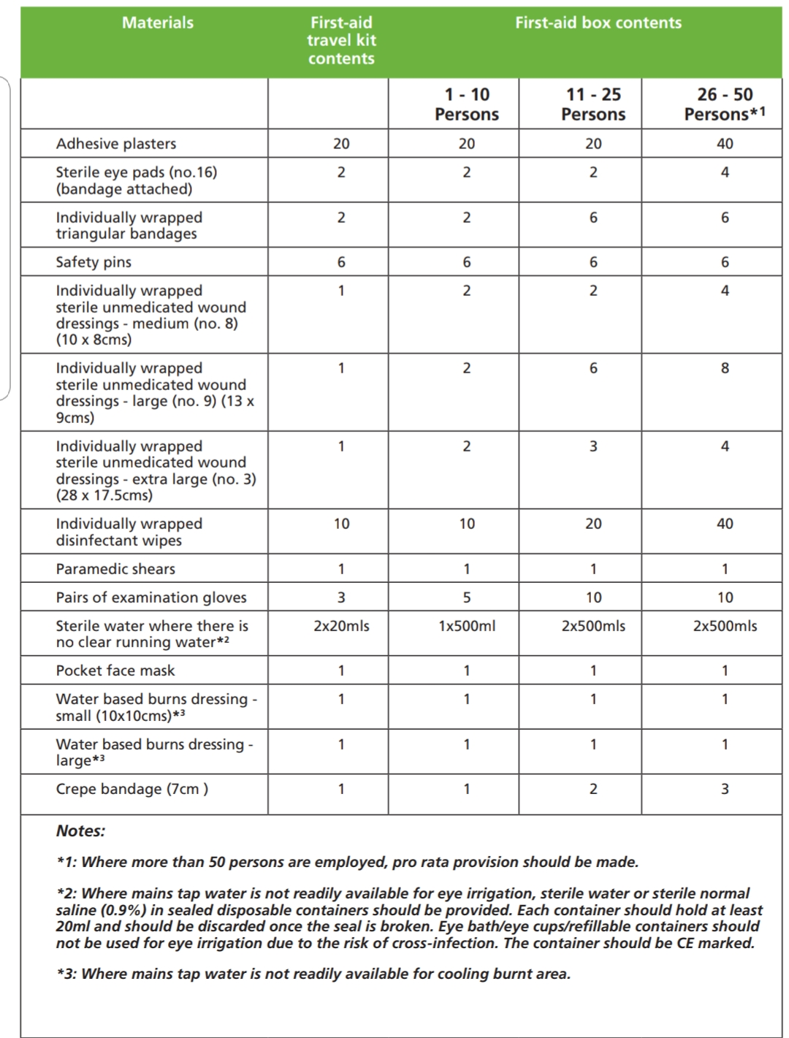

Appendix I:

Sample Accident or Incident Record Form (H.S.A 2013)

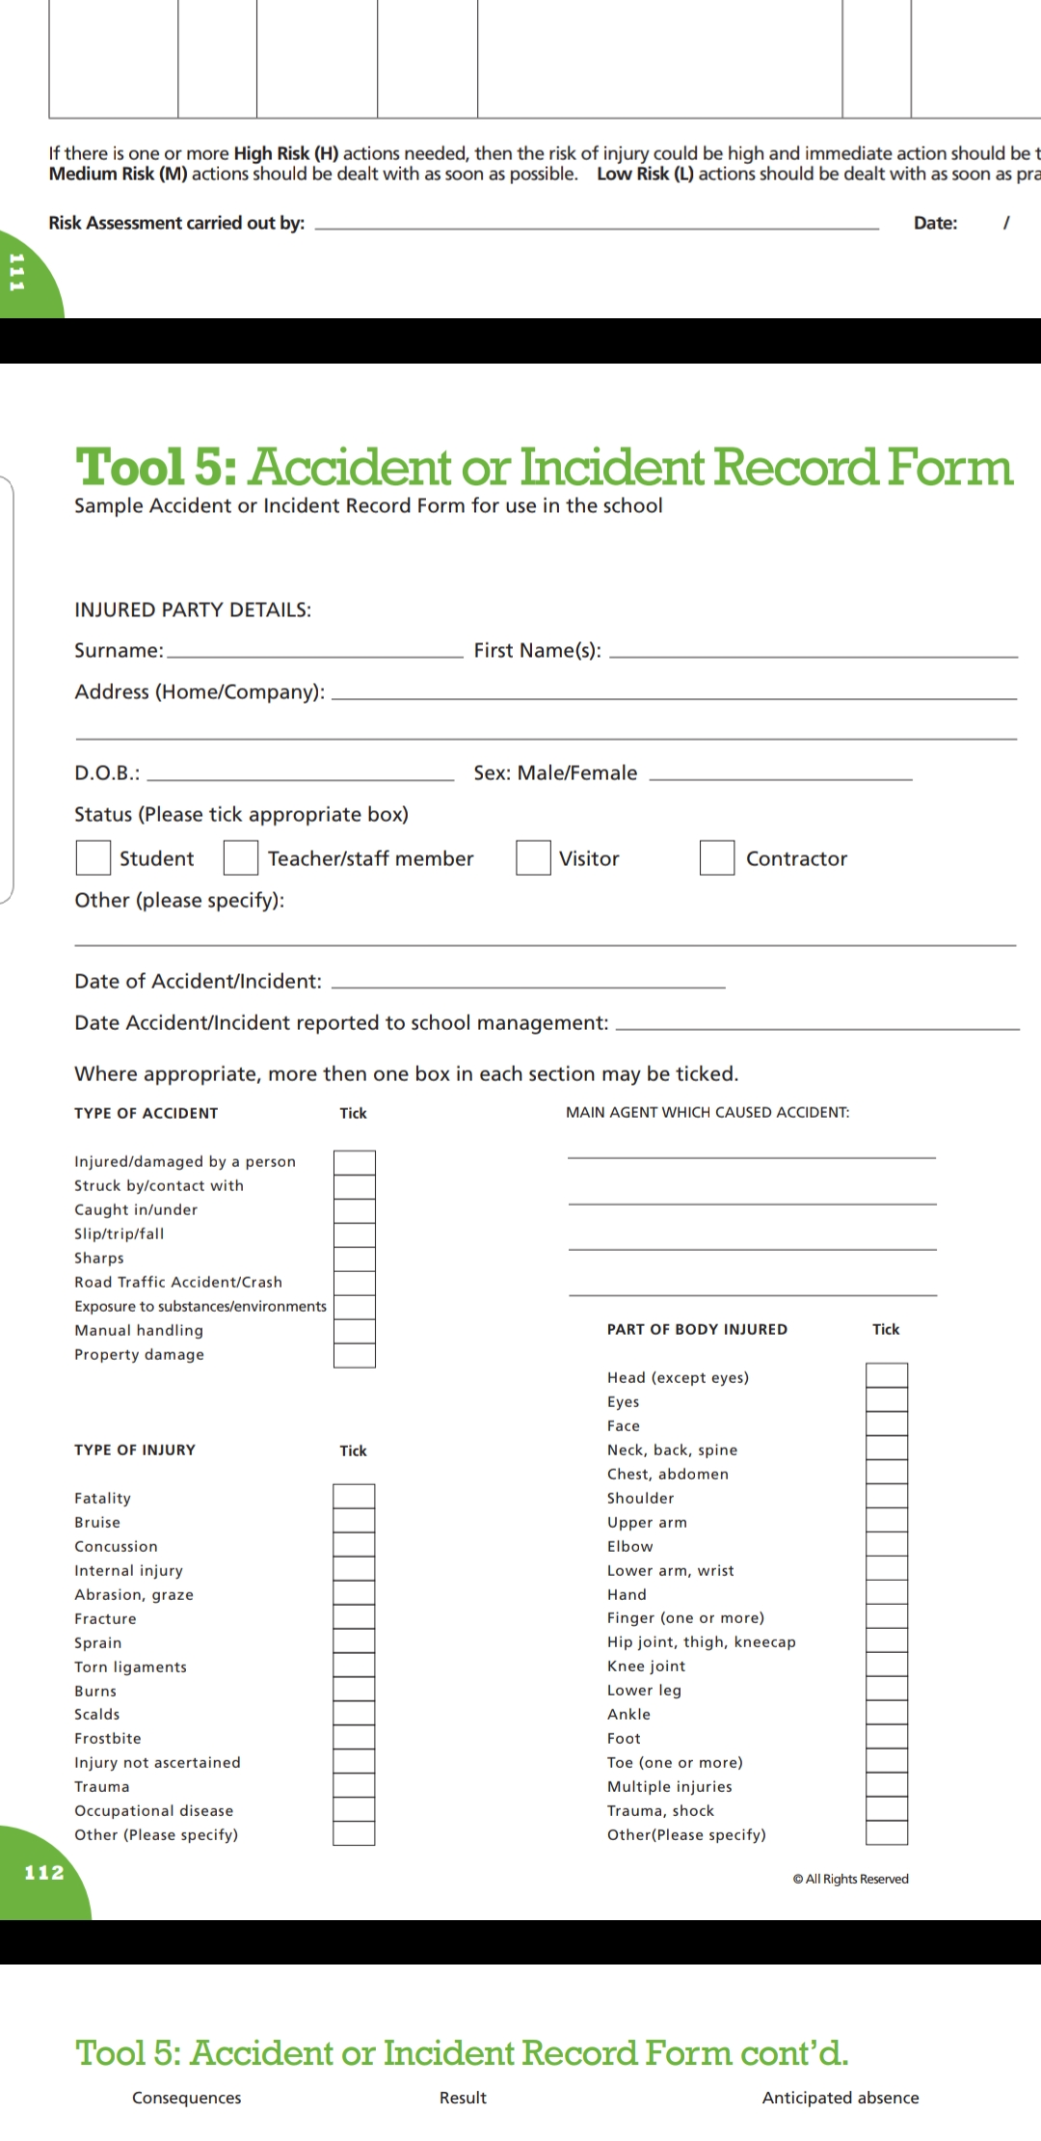
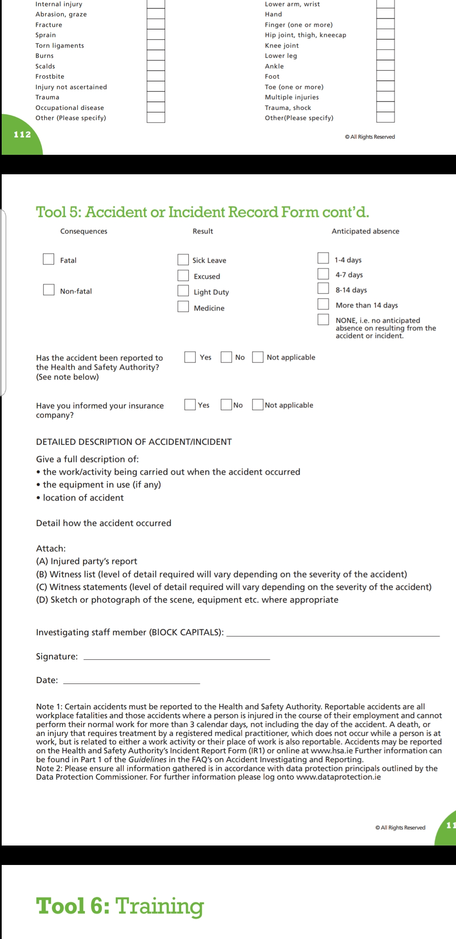

Appendix J:

HSA guidance on Workplace stress

Preventing stress in the Workplace (H.S.A 2013)
Work Related Stress (WRS) is stress caused or made worse by work. It simply refers to when a person perceives the work environment in such a way that his or her reaction involves feelings of an inability to cope. It may be caused by perceived/real pressures/deadlines/threats/anxieties within the working environment. We each perceive, interpret, cope with and react to the world differently, but a stress reaction is an unpleasant state of anxiety. Being stressed may not be articulated by everyone in the same way for instance, although we all experience stress through loss, people will explain the experience differently, cope with it differently, acknowledge it differently and recover from it in many different ways. There are healthy ways to overcome stress – good lifestyle, diet, social solidarity, meaningful work which can broaden our social ties – as well as unhealthy ways to react – such as over- or undereating, excessive drinking, angry outbursts, defensiveness – which can lead to lack of quality sleep, decreased exercise and social isolation. Workplaces which have good communications, respectful relations and healthy systems of work can help people recognise and manage the type of stress which may have more than one cause; such workplaces tend to get the best results in achieving a healthy and productive workforce. An audit tool which was developed in partnership with the Health and Safety Executive in the UK and is used in the UK and Ireland is known as the Management Standards in the UK and in Ireland as Work Positive. This tool is a survey method of assessing employee perceptions of WRS in terms of what leads up to the experience and how these are managed at the workplace. Updated and upgraded in Ireland in 2011, the survey gives a well-being profile to participating organisations, identifying trends within certain sectors and industry types and providing a benchmark for Irish organisations in order to compare improvements year on year. It is available to download in paper format or to do anonymously on-line through our hosting partners accessed through the HSA website:
www.hsa.ie/workpositive

Appendix K:

Advice on reducing the risk of injury related to Manual Handling (HSE UK)

To help prevent manual handling injuries in the workplace, you should avoid such tasks as far as possible. However, where it is not possible to avoid handling a load, employers must look at the risks of that task and put sensible health and safety measures in place to prevent and avoid injury.

For any lifting activity
Always take into account:
- individual capability
- the nature of the load
- environmental conditions
- training
- work organisation

If you need to lift something manually
- Reduce the amount of twisting, stooping and reaching
- Avoid lifting from floor level or above shoulder height, especially heavy loads
- Adjust storage areas to minimise the need to carry out such movements
- Consider how you can minimise carrying distances
- Assess the weight to be carried and whether the worker can move the load safely or needs any help – maybe the load can be broken down to smaller, lighter components
There are some simple things to do before and during the lift/carry:
- Remove obstructions from the route.
- For a long lift, plan to rest the load midway on a table or bench to change grip.
- Keep the load close to the waist. The load should be kept close to the body for as long as possible while lifting.
- Keep the heaviest side of the load next to the body.
- Adopt a stable position and make sure your feet are apart, with one leg slightly forward to maintain balance
Think before lifting/handling. Plan the lift. Can handling aids be used? Where is the load going to be placed? Will help be needed with the load? Remove obstructions such as discarded wrapping materials. For a long lift, consider resting the load midway on a table or bench to change grip.
Adopt a stable position. The feet should be apart with one leg slightly forward to maintain balance (alongside the load, if it is on the ground). Be prepared to move your feet during the lift to maintain your stability. Avoid tight clothing or unsuitable footwear, which may make this difficult.
Get a good hold. Where possible, the load should be hugged as close as possible to the body. This may be better than gripping it tightly with hands only.
Start in a good posture. At the start of the lift, slight bending of the back, hips and knees is preferable to fully flexing the back (stooping) or fully flexing the hips and knees (squatting).
Don’t flex the back any further while lifting. This can happen if the legs begin to straighten before starting to raise the load.
Keep the load close to the waist. Keep the load close to the body for as long as possible while lifting. Keep the heaviest side of the load next to the body. If a close approach to the load is not possible, try to slide it towards the body before attempting to lift it.
Avoid twisting the back or leaning sideways, especially while the back is bent. Shoulders should be kept level and facing in the same direction as the hips. Turning by moving the feet is better than twisting and lifting at the same time.
Keep the head up when handling. Look ahead, not down at the load, once it has been held securely.
Move smoothly. The load should not be jerked or snatched as this can make it harder to keep control and can increase the risk of injury.
Don’t lift or handle more than can be easily managed. There is a difference between what people can lift and what they can safely lift. If in doubt, seek advice or get help.
Put down, then adjust. If precise positioning of the load is necessary, put it down first, then slide it into the desired position.Available at: http://www.hse.gov.uk/pubns/cais24.pdf

Appendix L:

HSE guidance on correct use of VDU equipment

Ensure workstations meet minimum requirements
These requirements are good features that should normally be found in a workstation, such as adjustable chairs and suitable lighting. They are set out in a schedule to the Regulations, covering screens, keyboards, desks, chairs, the work environment and software. All workstations covered by the Regulations now have to comply, to the extent necessary for the health and safety of workers (a transitional period for modification of older workstations expired at the end of 1996).
Plan work so there are breaks or changes of activity
As the need for breaks depends on the nature and intensity of the work, the Regulations require breaks or changes of activity but do not specify their timing or length. However, the guidance on the Regulations explains general principles, for example short, frequent breaks are better than longer, less frequent ones. Ideally the individual should have some discretion over when to take breaks.
On request arrange eye tests, and provide spectacles if special ones are needed
Employees covered by the Regulations can ask their employer to provide and pay for an eye and eyesight test. This is a test by an optometrist or doctor. There is also an entitlement to further tests at regular intervals; the optometrist doing the first test can recommend when the next should be. Employers only have to pay for spectacles if special ones (for example, prescribed for the distance at which the screen is viewed) are needed and normal ones cannot be used.
Provide health and safety training and information
Employers have to provide training, to make sure employees can use their VDU and workstation safely, and know how to make best use of it to avoid health problems, for example by adjusting the chair. Information should also be provided about VDU health and safety. This should include general background information - this could be done by giving out copies of this booklet. It should also cover more specific details of the steps taken by the employer to comply with the Regulations, such as the action taken to reduce risks and the arrangements for breaks.
Available at: https://www.ucu.org.uk/media/2765/Working-with-VDUs---HSE-leaflet/pdf/hse_vdu.pdf

