

******Scoil Mhuire, Cloonanaha**

Ph: 065 6836916

Email:scoilcluain@gmail.com

Website: [www.cloonanahans.com](http://www.cloonanahans.com)

**March 2023**

Dear Parents,

Well done to all the boys and girls who have settled back to school so well over the past few weeks.

**Date for your diary**

St. Patrick’s Day Friday 17th of March: School closed

Easter holidays: Friday March 31st at 12.30pm

Return to school on Monday the 17th of April

**Non-Uniform Day**

We will have a non-uniform day on Friday the 31st of March

**Confirmation and Confession**

Best of luck to our pupils who are busy preparing for their Confession, Communion and Confirmation. Confirmation will be held on the 22nd of April. This year’s confession will take place on the 30th of March at 2pm.

**Ennistymon Choral Society**

All pupils will travel to Ennistymon on Tuesday 18th April to view a matinee performance by the Ennistymon Choral Society. The cost is €7 per pupil. We are looking forward to a lovely day out.

We are delighted to have received lots of interest in enrolment for September 2023. Enrolment forms can be requested from the office or can be downloaded from our website.

We will hold an open day on Wednesday 26th of April for prospective parents. All are welcome.

Please email scoilcluain@gmail.com if you require any further information.

**Swimming**

Our final swimming session is on at Lahinch Pool on Wednesday the 22nd of March at 12pm as usual.

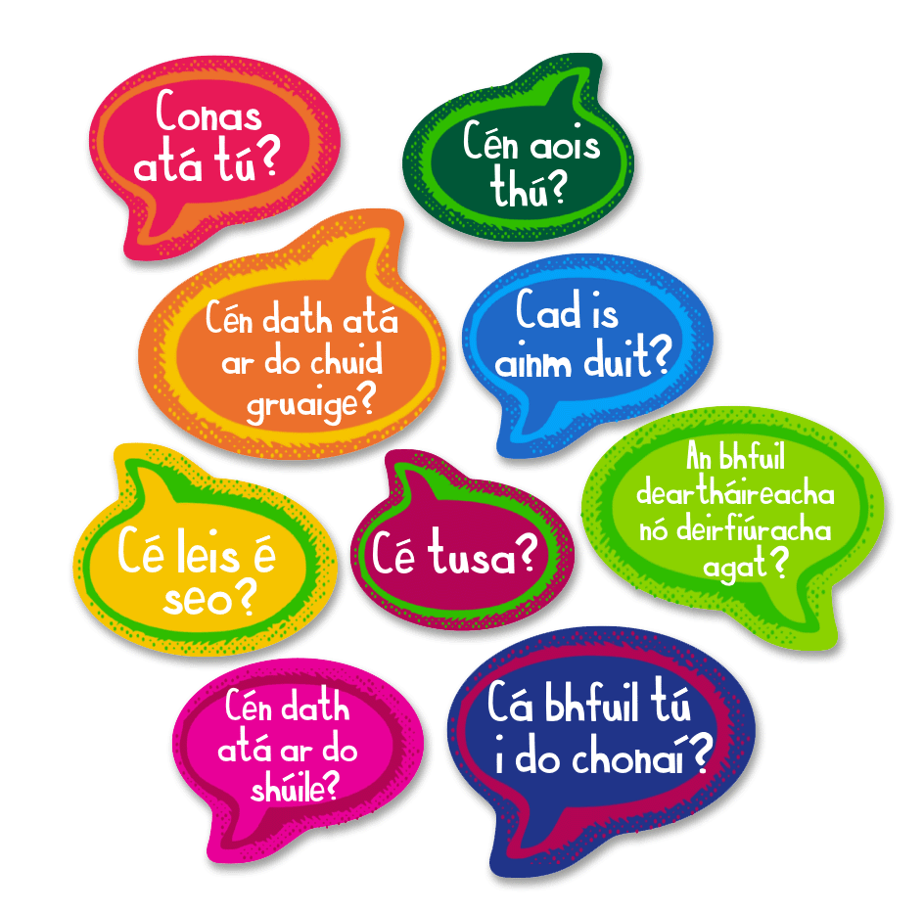Seachtain na Gaeilge

We will celebrate Seachtain na Gaeilge from the 13th – 16th of March. We will mark this special week by trying to use as much Gaeilge as we can and also celebrate our culture with some Irish music. We will hold a Lá Glas on Thursday 16th March. This will be a non-uniform day where we invite children to dress in green.

……………………………………………………

Go raibh míle maith agaibh

**Mr Seán O’Grady**

**Principal**